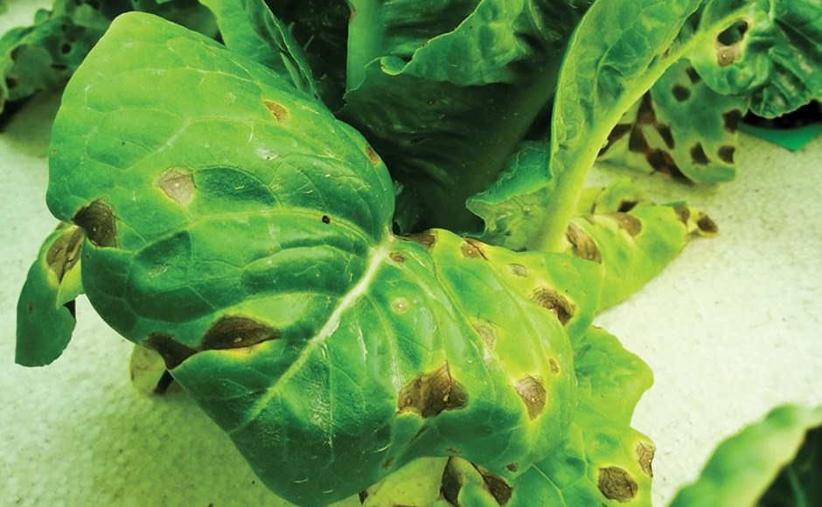

How to Prevent Your Plants from Getting Nutrient Burn

**Takeaway:** *If you give your plants too much love, it’s possible you’ll both feel the burn. Here's how to avoid the dreaded nutrient burn in your garden.*

Like all good plant parents, you lovingly provide all the things that your plants need: water, light, nutrition, maybe even positive reinforcement that they are being the best they can be.

Yet, despite your exemplary efforts, you notice discoloration along the margins of your leaves. You have given your plants too much of a good thing and now they are showing signs of [nutrient burn](https://www.maximumyield.com/definition/2157/nutrient-burn).

Don’t worry; it happens to even the most professional of growers sometimes. Your municipality’s plant protective services will not be alerted and you won’t be hauled off to jail for plant abuse. However, you do need to jump into action to try and save those plants before it is too late.

**Nutrient Burn Causes and Symptoms**

Proper plant growth requires a balancing act of about 16 different [macronutrients](https://www.maximumyield.com/definition/169/macronutrient) and [micronutrients](https://www.maximumyield.com/definition/173/micronutrient). If a plant receives too much of any of these, it can get nutrient burn.

In hydroponic systems, nutrient burn often occurs when the levels of fertilizer salts—measured by [electrical conductivity (EC)](https://www.maximumyield.com/definition/157/electrical-conductivity-ec)—are too high. Excessive nutrients are harder to control in most hydro systems because all the plants are exposed to the same nutrient solution (as opposed to soil systems, where the issue can sometimes be isolated to a single plant).

To confuse the matter, nutrient burn can also occur when [fertilizer levels](https://www.maximumyield.com/definition/202/fertilizer) are on point. In this case, the plant is stressed by other factors, such as pests or diseases, and cannot utilize all the nutrients that it is provided with.

Different types of plants present symptoms of burn differently depending on which nutrient or nutrient combination caused problem. Typically, however, a plant with nutrient burn will develop brown or dead spots along the leaf tips.

Sometimes, this discoloration will travel along the edges of the leaf to its base. (The excess nutrients accumulate at the ends of the leaf because they can’t travel any further.) The brown is sometimes separated from the healthy, green plant tissue by a halo-like yellow margin.

Excess nutrient accumulation doesn’t always show up as burns on the leaves, however. Too much [nitrogen](https://www.maximumyield.com/definition/176/nitrogen-n) may in fact make the plant look temporarily lush and full of foliage while its fruits prematurely drop and the roots shrivel up, leading to death in the plant.

It’s important to note that when in the leaves, nutrient burn looks like a condition known as leaf scorch. Leaf scorch is caused by water leaving the leaves via respiration faster than the plant can replace it, such as during extremely hot, sunny weather. Coincidentally, nutrient burn is exacerbated by hot, dry weather, making the identification of symptoms more challenging.

Another issue that looks like nutrient burn can occur if the plants are grown under grow lights. If they are too close to the light source, the tips of the leaves can burn. The solution in this case is to either raise the lights or move the plants a bit further away from the heat source.

**Fixing and Avoiding Nutrient Burn**

Thankfully, it is possible to bring your plants back from nutrient burn. The brown on the margins of the leaves is not going to turn green again, but new leaf growth should be unaffected if all goes well.

When nutrient burn occurs, the excess nutrients need to be flushed out or removed entirely and the proper ratio of nutrients needs to be re-established. For crops grown in soil, irrigate heavily to leach out the excess nutrients.

Distilled water is the best option as it will not inadvertently exacerbate the problem by adding more nutrients. Also, if granular fertilizer is applied, make sure to sweep, blow, or brush off anything that may have landed on the leaf surface.

If nutrient burn occurs in a [hydroponic system](https://www.maximumyield.com/definition/70/hydroponics), drain the water from all of the reservoirs and refill with clean water. Let the system run for 24 hours with the new water, then assess the EC level. If it still seems high, drain the system, refill again, and test after another 24 hours. Repeat the process until the EC is at an acceptable level.

Once the excess nutrients are flushed out, determine what caused the problem if you can. If it is not immediately obvious, reduce the amount of fertilizer you would normally apply by half.

If burn symptoms do not reappear, keep incrementally raising the amount of nutrients that you feed your crops. Do this until normal levels have been reestablished and no further symptoms of nutrient burn arise.

Knowing what your crop needs and knowing what is already in the soil or water will help to avoid nutrient burn. Getting a [soil analysis](https://www.maximumyield.com/understanding-the-five-most-important-parameters-on-your-soil-test-report/2/2874) with a nutrient profile before starting any new crop is always a good idea.

The results will help you figure out what your soil or water reservoir may need for your crops to thrive. Most land grant universities will offer this service through their cooperative extensions for a nominal fee, or they can recommend a lab that does this.

There are also numerous do-it-yourself testing kits on the market that are inexpensive and easy to use/decipher. If there is still any question about how to read the results, don’t guess! Ask a professional at either your local extension office or a reputable garden store in your area.

Also, remember that different types of crops have different nutrient needs. In general, leaf crops like lettuces and spinach, as well as many herbs, require higher amounts of nitrogen; crops that are grown for their fruit, including tomatoes, peppers, eggplants, and cucumbers, should maintain relatively lower nitrogen levels; and crops that are grown for their roots, such as carrots, parsnips, and radishes, need higher amounts of [potassium](https://www.maximumyield.com/definition/182/potassium-k).

Crops in different phases of development have differing nutrient needs, too, so it’s important to know what your plant needs the most of when it is in a vegetative phase or a bloom phase. Also, crops that are grown indoors or under artificial light have different nutrient needs than those grown outdoors.

In general, plants tend to need more nitrogen when they receive full daylight or are exposed to high levels of artificial light. When natural light levels are lower during late fall and winter months, most fruit-producing plants need more [potassium](https://www.maximumyield.com/definition/182/potassium-k). The ratio of potassium to nitrogen can be raised to twice its usual amount during the winter months, and returned to its usual ratio in the spring.

Once you know what it is your plants need to achieve better yields, applying the nutrients correctly cannot be under-emphasized. A common mistake among newer growers is to misinterpret the numbers on a bag or bottle of fertilizer or not make the necessary conversions. This is especially true when using a concentrated fertilizer that needs to be mixed before use.

Applying a concentrated fertilizer directly onto your plants will definitely cause burn and probably even kill them. This is the same reason why you should handle and mix concentrated nutrients in an area away from your crops; you don’t want the material to touch your plants or end up in your reservoir if a spill were to occur.

Finally, nutrient burn in soil-grown plants can be almost completely avoided with the use of slow-release or organic fertilizers. These fertilizers deliver their nutrient package little by little over the course of a few months or an entire season, making them far less likely to cause damage.

Also, most [slow-release fertilizers](https://www.maximumyield.com/definition/650/slow-release-fertilizer) and [organic fertilizers](https://www.maximumyield.com/definition/1727/organic-fertilizer) do not break down when wet, instead releasing their nutrition through microbial activity in the soil ([water-soluble fertilizers](https://www.maximumyield.com/definition/711/water-soluble) should be avoided if nutrient burn is a concern). These fertilizers often have lower nutrient analyses listed on their packaging, so the consumer does not always believe they are getting the same bang for their buck.

The reality, though, is much of the nutrients found in water-soluble fertilizers can be lost through leaching if the plants are given more nutrients than they can use at one time, meaning the plant is only getting a small percentage of what is listed on the package.

So, there you have it. [Nutrient burn](https://www.maximumyield.com/definition/2157/nutrient-burn) is a common, fixable issue that even the most devoted plant parents can run into. Once your plants are back on track, just be sure to learn from your mistakes and stop smothering your little ones with too much love before you both get burned again.