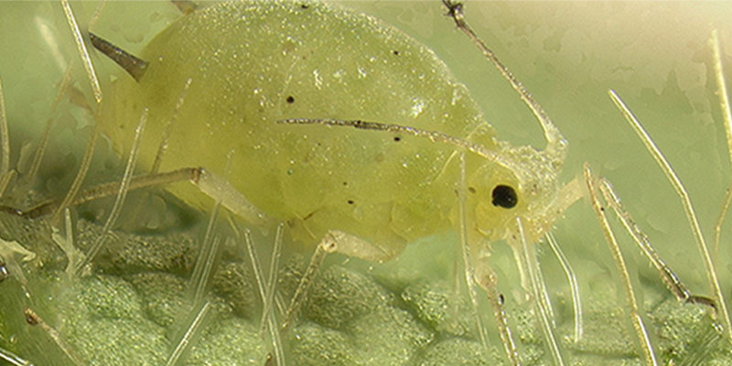

**Aphids On Marijuana Plants**

Aphids are winged insects that hide on the underside of your marijuana plants’ leaves, using their piercing mouths to bite a hole in your plant and suck the nutrients from the leaves until they yellow and wilt.

They can be green, yellow, black, brown, or red. They have oval-shaped bodies, and you might be able to see their wings and antennae.

Although aphids do consume precious nutrients from your plants, that is not the only reason they are problematic for your plants. They also might carry viruses and give them to your marijuana plants, and these viruses could in turn stunt your plants’ growth and slow down flower production. Some aphid species actually inject toxins into your plants – and this has a serious impact on your crop.

**Signs of aphids**

[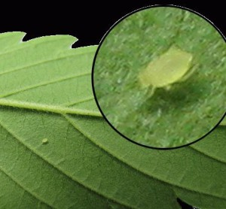](http://www.ilovegrowingmarijuana.com/wp-content/uploads/2013/10/signs-of-aphids-on-marijuana-plants.jpg)

Unlike [spider mites](http://www.ilovegrowingmarijuana.com/spider-mites-pests/), aphids are happiest at a temperature between 60 and 80 degrees Fahrenheit. When they snack on your marijuana plants, they drop a substance that is sweet and therefore called “honeydew”. The [honeydew](https://en.wikipedia.org/wiki/Honeydew_(secretion)) often results in sooty mold growing on it, which turns your plants’ leaves black and may attract ants. Therefore, aphids reduce your plant’s nutrients, potentially give your plant a virus, *and* attract other pests to come snack on your plant.

The honeydew (aphid waste) starts growing sooty mold, which will build up on your plants’ leaves and branches, eventually turning them black. This is often the sign anyone notices of an aphid infestation that has been building for a while.

The most important step in taking care of an aphid problem is noticing it early on. You won’t be able to predict when winged aphids might come and start producing offspring on your plants, but you *can* do a routine check at least once per week. You should keep an especially close eye on the areas around your plant’s buds, as well as new leaves. You will be able to see new aphid clusters or colonies, which indicates that these pests are already well established on this particular plant.

Not sure if aphids are causing the damage to your marijuana plants? Check the article [Marijuana pest and bug control](http://www.ilovegrowingmarijuana.com/pests-bugs-marijuana-control-identification/) for a list with pictures of all pests and bugs

**How to get rid of aphids**

[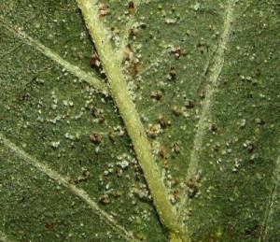](http://www.ilovegrowingmarijuana.com/wp-content/uploads/2013/10/get-rid-of-aphids-on-marijuana-plants.jpg)

Luckily for you, aphids are sometimes naturally taken care of with really serious infestations. Wasps will come and actually lay their eggs inside of the aphids, thus “parasitizing” these pests. The aphids start forming a mummy shell that is thin and crusty, at which point that aphid is not longer a danger to your plant’s health.

Ladybugs are another predator of aphids. If you suddenly notice a lot of ladybugs in your marijuana garden, you can be confident that there is an aphid problem. Don’t panic, however – the ladybugs will eat them up and get them back under control. This is Mother Nature’s way of dealing with overpopulations and infestations. You can buy 1500 live ladybugs online for only $9 at [this link here](http://amzn.to/1eF8gkd)

While Mother Nature takes her course of action, you should take yours and help her along a bit. There are two home remedies that you can use as organic sprays to take care of your aphid problem. The first spray, tomato leaf spray, works especially well if you also are caring for tomato plants.

To do this, you simply combine two cups of water with two cups of chopped tomato leaves and let it steep for one entire night. You can then remove the leaves by straining the liquid, and pour the remaining liquid into a clean spray bottle, then add two more cups of regular water. You can then use this spray on the leaves of your marijuana plants – focus especially on the bottom side of leaves, where aphids like to live.

Another option for a similar mixture is finely chopping an onion and two garlic cloves, then blend them with two cups of water. Strain the pulp out and spray the mixture on your plants.

If tomato leaf spray isn’t your style, you can try an organic garlic oil spray instead. It kills all sorts of pests (one of which is aphids) and also has antibacterial and antifungal properties that will keep harmful diseases away. To make it finely chop three or four cloves of garlic and combine it with two teaspoons of mineral oil. This should be left to sit for 24 hours, after which you should strain it into a gallon of water, then add a teaspoon of liquid dish soap. You should then store the resulting mixture (i.e. in a plastic jug), and use only two tablespoons combined with a full spray bottle of water.

With the garlic oil spray, you should definitely check that it won’t damage your plants before spraying the entirety of your garden with it. Take the solution in the spray bottle and spray it on one leaf of a marijuana plant. Then let it sit for one to two days and return to it to check if there is any leaf damage. If there is (characterized by yellowing), then you should dilute the mixture even more and test the solution on a new leaf each time. Once you successfully have no leaf damage, you can spray the full plant with it – once again, focus especially on the bottom sides of leaves.

A commercial product like Bug Blaster will always to the job. If you want to be sure to kill them all buy something like [Bug Blaster](http://shop.ilovegrowingmarijuana.com/products/marijuana-plant-protector).

There are still more ways to control an aphid problem. You can use fatty acid salts or insecticidal soaps to disrupt the cell membranes of insects, therefore killing them. They don’t have any negative effects on your plants, and they need to be applied directly to the aphids. Other options include nervous system insecticides like malathion, Dursban (chlorpyrifos), and Orthene (acephate). These insecticides will claim on the label to be for shade trees and ornamental plants, but will also work for your marijuana plants.

With any of these substances, you may need to reapply it once. It is not recommended that you use Sevin, which could have a negative impact on those insects that you do want around (such as ladybugs, lady beetles, and lacewings). These bugs will keep aphids at bay.

**Marijuana plant symptoms**

– Leaves turning yellow in color  
– Leaves wilting  
– Plant wilting  
– Bugs  
– Aphid clusters or colonies on leaf undersides  
– Clusters or colonies near new growth  
– Clusters or colonies near buds

Aphids give birth to live offspring (rather than laying eggs) as much as twelve times per day. Female aphids are capable of producing between 40 and 60 offspring total, and this offspring will reach maturity within 7 to 10 days. This leads to a huge population boom. Hundreds or even thousands could be living and munching happily on your plant in a matter of weeks. Winged aphids only happen when the species is stressed enough (or has consumed enough of your plant) and needs to search out new habitats. It will do this by flying away (probably to one of your other plants).

Remember that plants with strong genetics have less change of getting sick and are less vulnerable for pests and diseases. So make sure to [buy cannabis seeds](http://shop.ilovegrowingmarijuana.com/) from a trusted seed bank.