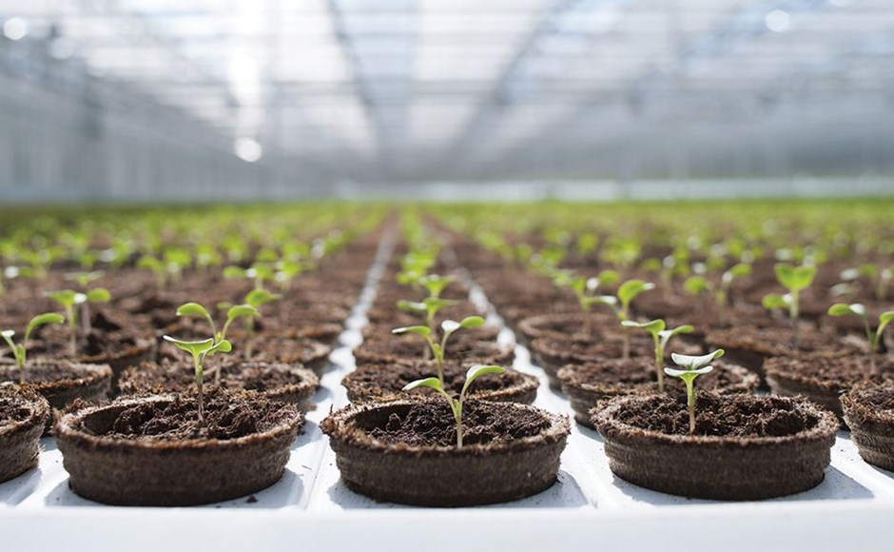   
  
3 Ways to Take Your Grow to the Next Level

**Takeaway:** *So, you think you’ve mastered the art of small-scale growing and you’re ready to take it to the next level? Here are the top three worthwhile investments for novice growers transitioning into more advanced operations.*

Scaling up can be an exciting yet intimidating move to make, considering the amount of investment of time and money required to do it right. To assist, I’ve identified three tools and implementations that will ultimately save you thousands of dollars when used properly.

**Biocontrol**

Simply put, biocontrol is a chemical-free alternative to traditional pesticides. It has yet to get a whole lot of publicity in the modern growing industry, but it is about to get huge—and fast. States across the country are mandating laws surrounding the use of chemical pesticides on consumable crops, and the rules are progressively getting stricter.

In some locations, the finished product must be tested for residual pesticides before hitting the shelf at retail locations. You can imagine how this could drastically interrupt growers’ operations and livelihoods if they are suddenly stuck with pounds and pounds of unsellable product that didn’t pass inspection. The good news is that there is a very effective way around this issue.

The method of utilizing natural enemies—biocontrol—has been around for years in commercial agriculture. The use of beneficial insects creates an environment that is not conducive for pests to survive and reproduce, while simultaneously eliminating the use of chemical pesticides altogether.

Sure, the cost of implementing a biocontrol regimen into your grow is higher than using chemical pesticides, but there is an upside to that too. Growers can charge a higher price, as consumers are often willing to pay for a pesticide-free product.

Between that and the quality-savings reaped from eliminating chemicals from your grow, as well as the yield-savings potential through the prevention of damage from even small colonies of pests, growers end up boosting profits significantly.

**Light Meters**

Light meters are a somewhat hidden gem in the modern growing industry. Many growers don’t bother to make the rather modest investment of approximately $150 because they don’t think they need it.

Well, when you consider the amount of money you put into your lighting system, protecting that investment becomes critical. It is important to be aware of how much light output you are getting from both your bulbs as well as your reflectors.

Most manufacturers give an estimated lifespan for their bulbs, but this can be within a wide range, depending on other variables that contribute to the speed at which a bulb degrades: functionality of the ballast, environmental factors such as cleanliness and temperature, and age of the bulb.

Using a light meter can clue you into possible malfunctions, as well as indicate when a bulb is not performing optimally. Because yield is directly related to light, it will suffer if the output isn’t functioning at its highest potential.

“If growers purchase a light meter and use it properly, it will pay for itself the first time you identify a bad bulb,” advises Cameron Laubisch, lead engineer for Nanolux Technology. He also notes how important it is to stay on top of your reflectors’ effectiveness. “Most people know to change the bulbs, but almost nobody changes reflectors, and they are supposed to change once a year.”

Over time, residue from humidity, foliar feeding, and other environmental contaminants collect on the surfaces of the reflectors, reducing the light output and their overall effectiveness.

You can help maintain a reflector for longer periods of time by wiping them down periodically to reduce buildup from blocking its output, but the heat and light itself also contribute to degrading reflectors. Eventually, regardless of how clean you keep them, they will need to be replaced, and a light meter can tell you that information under no uncertain terms.

**Media Sensors**

Sensors are something of a hot topic within the modern grow sphere. For those growing hydroponically, there are various sensors available that should be considered when scaling up. Besides the usual pH, TDS/EC, and temperature meters, other sensors such as [oxidation reduction potential (ORP)](https://www.maximumyield.com/definition/3237/oxidation-reduction-potential-orp) meters and ion-selective electrodes can be very useful for a grower looking to streamline.

ORP meters essentially inform the grower about how healthy their water is. Keeping that number at 420 mV or higher helps to maintain a sterile environment, free of harmful bacteria, which is generally how hydroponics systems are most efficiently run.

Ion-selective electrodes break down the standard TDS meter into readings by specific ion. This helps growers make informed decisions as to their feeding schedule while monitoring nutrient levels and making sure these levels are on target.

When these ratios fall short in any one direction, this is when nutrient imbalances tend to occur. Nutrient sensors can be considered a part of preventative maintenance to help diagnose issues before it’s too late, as well as a tool to achieve a higher level of sustainability.

For those in a soil setting, maintaining proper soil moisture is essential for growing healthy plants. It is such a common error to either overwater or under water plants, and there is an easy way around this otherwise serious issue when it is overlooked.

In less than 60 seconds, growers can insert the sensor into the soil and determine whether the soil moisture level is too high, too low, or right where it needs to be. The problem with diagnosing soil moisture with the naked eye is that under watered and overwatered plants often exhibit very similar symptoms.

The trend seems to lean more toward overwatering than under watering, which is an inefficient way to operate a grow facility, not to mention very environmentally unfriendly. It is important to optimize your irrigation system to ensure your plants aren’t suffocating from a lack of oxygen due to the soil moisture content staying too high.

Some growers are even integrating soil moisture sensors with irrigation controllers that will automatically adjust based on the conditions picked up by the meter. After all, this is the age of automation, so why stop now?

Protecting your investment with additional economically sound investments is the best way to cut costs and increase profits. While it is important to maintain and optimize all the fundamentals inside a grow space, when scaling up it is equally if not more important to protect what you already have.

These three tips may not be for everyone, but for those who are getting serious about growing and spending thousands of dollars a year on going pro with what used to be a hobby, you really can’t go wrong.